18-05-2022

Spring Framework DI using XML and annotation

Spring data source and jdbc

DataSource : DataSource features help to provide the data base connectivity using application server as a singleton database connection.

@Repository : This annotation we have to use on dao layer. Inside that layer we can write the code using jdbc or orm.

@Service : This annotation is service layer specific annotation.

Spring Dao : Spring framework provided pre-defined class ie JdbcTemplate which internally wrap jdbc api and provide more functionality to improve jdbc coding.

19-05-2022

Spring MVC : Spring MVC is a type of module provide the spring framework which internally follow MVC architecture. It provided lot of api to improve view layer, controller layer and model layer.

Spring MVC follow FrontController design pattern. It provided one of pre-defined class ie DispatcherServlet. Which we have to configure in web.xml file or using java classes.

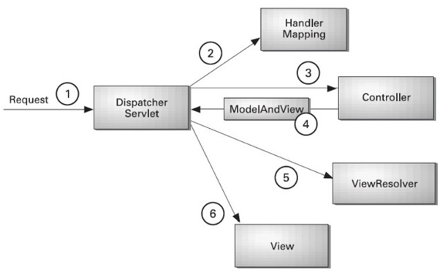

DispatcherServlet front controller search the xml file start with pre-fix dispatcher-servlet.xml

Signin.jsp Login.java

Signup.jsp LoginController.java LoginService LoginDao

DI for JdbcTemplate

dispatcher-servlet.xml file

<context:component-scan base-package=*"com"*></context:component-scan>

<bean id =*"ds"* class=*"org.springframework.jdbc.datasource.DriverManagerDataSource"* scope=*"singleton"*>

<property name=*"driverClassName"* value=*"com.mysql.cj.jdbc.Driver"*></property>

<property name=*"url"* value=*"jdbc:mysql://localhost:3306/batch7"*></property>

<property name=*"username"* value=*"root"*></property>

<property name=*"password"* value=*"root@123"*></property>

</bean>

<bean id=*"jdbcTemplate"* class=*"org.springframework.jdbc.core.JdbcTemplate"* scope=*"singleton"*>

<property name=*"dataSource"* ref=*"ds"*></property>

</bean>

Dependencies

Only

Spring mvc

And mysql connector